MLA0104 – ARTIFICIAL INTELLIGENCE AND EXPERT SYSTEMS
COURSE ASSIGNMENT
Intelligent Disaster Response and Rescue Decision-Support Agent
A. Assignment Information
Particular | Details
Department | AI & ML
Programme | As applicable
Course Code & Course Name | MLA01 – Artificial Intelligence and Expert Systems
Academic Year / Batch | _____2026_______________________
Faculty Name | ____DR.M. PRAKASH________________________
Assignment | Assignment 2
Assignment Title | Design and Development of an Intelligent Disaster Response and Rescue Decision-Support Agent Using Search, Logic and Expert-System Techniques
Date of Issue | _01/09/2026___________________________
Date of Submission | _01/09/2026___________________________
Maximum Marks | 100
Course Outcome(s) – CO | CO1, CO2, CO3, CO4 and CO5
Bloom's Taxonomy Level | L3 – Apply, L4 – Analyse, L5 – Evaluate, L6 – Create

B. Assignment Problem / Challenge
Real-World Scenario
A city disaster-management authority wants to develop an Intelligent Disaster Response and Rescue Agent (IDRRA) to assist emergency teams during situations such as floods, earthquakes, industrial accidents and building collapses.
During a major disaster, multiple locations may simultaneously require attention. However, the response team has limited rescue vehicles, medical teams, fire and rescue personnel, emergency shelters, drones and communication resources.
The intelligent system must analyse information received from different locations and determine which location should be attended first, which route should be selected, what type of rescue team should be deployed, and what action should be performed.
The objective is to develop an AI-based decision-support prototype that integrates search, heuristic reasoning, logic, inference, expert systems, intelligent agents and learning.
Problem Statement
Consider the following disaster locations:
Location | Situation | Information | Available Resource  Requirement
L1 | Building collapse | 12 people trapped, smoke detected | Rescue + Medical
L2 | Flooded residential area | 20 people stranded, rising water | Rescue Boat
L3 | Industrial accident | Fire, toxic gas suspected | Fire + Hazmat
L4 | Road accident | 4 injured people, ambulance access available | Medical Team

The disaster-control centre has limited resources and must decide:
• Which location should receive the highest priority?
• Which rescue team/resource should be assigned?
• Which route should the rescue vehicle follow?
• What sequence of actions should be performed?
• What possible emergency condition can be inferred from the available facts?
• How can the system explain its recommendation?
• Which intelligent-agent architecture is most appropriate?
• How can the system learn from previous disaster-response cases?
C. Requirements and Constraints
Functional Requirements
• Formulate the disaster-response problem as an AI problem and define the initial state, goal state, states, actions/operators, path cost, constraints, available knowledge and expected output.
• Model the rescue operation as a state-space search problem.
• Select A*, Greedy Best-First Search or another suitable search algorithm and define an appropriate heuristic. • Represent disaster-related knowledge using propositional logic and first-order logic.
• Demonstrate unification and resolution for disaster-response queries.
• Develop a rule-based disaster-management expert system containing at least 10 production rules. • Demonstrate both forward chaining and backward chaining.
• Design and justify an appropriate intelligent-agent architecture.
• Explain how the agent can learn from previous disaster-response cases.
• Develop an integrated prototype or simulation and provide execution evidence.
• Validate the system using at least four disaster scenarios and analyse the results.
Constraints
• Students must clearly state assumptions regarding roads, resources, locations and emergency conditions. • The reasoning process and recommendations must be explainable.
• Students should compare alternative search/agent strategies and justify the final approach.
• Limitations and broader considerations such as reliability, safety, communication failures, bias, privacy and human oversight must be discussed.
D. Student Work
1. Problem Understanding and Formulation – 10 Marks
Formulate the disaster-response problem as an AI problem. Explain the assumptions made regarding roads, resources, locations and emergency conditions.
Expected output – prepare the following table:
Component | Student's Description
Initial State | The disaster-control center receives information about four emergency locations L1, L2, L3, and L4, along with the available rescue teams, vehicles, roads, and other limited resources.
Goal State | The goal is to successfully respond to all critical disaster locations by prioritizing emergencies, assigning suitable rescue resources, selecting efficient routes, and ensuring that affected people receive timely assistance.
States | The states represent the current condition of each disaster location, including the number of trapped or injured people, fire or toxic gas presence, water level, available resources, road conditions, and the progress of rescue operations.
Actions / Operators | The possible actions include identifying the highest-priority disaster, dispatching rescue teams, assigning medical or Hazmat teams, sending rescue boats, selecting a suitable route using A* search, evacuating people, and updating the response based on new information.
Path Cost | Path cost represents the total cost of travelling from the disaster-control center to a disaster location. It can include distance, travel time, road difficulty, risk level, and other factors affecting emergency response.
Constraints | The system must operate with limited rescue teams, vehicles, medical resources, and communication facilities. It must also consider blocked or risky routes, changing disaster conditions, limited response time, and the safety of rescue personnel.
Available Knowledge | The system uses disaster facts such as location, disaster type, number of affected people, fire, smoke, toxic gas, rising water, injuries, road accessibility, available resources, logical rules, heuristic values, and previous disaster-response cases.
Expected Output | The system uses disaster facts such as location, disaster type, number of affected people, fire, smoke, toxic gas, rising water, injuries, road accessibility, available resources, logical rules, heuristic values, and previous disaster-response cases.

2. Search and Heuristic Techniques – 15 Marks
• Model the rescue operation as a state-space search problem.
• Construct the state-space representation.
• Select A*, Greedy Best-First Search or another suitable search algorithm.
• Define a suitable heuristic.
• Show the nodes/states explored.
• Calculate the path cost.
• Determine the best rescue route or action sequence.
• Justify why the selected solution is preferred.
For A*: f(n) = g(n) + h(n), where g(n) is the cost already incurred, h(n) is the estimated remaining cost, and f(n) is the estimated total cost. Explain why the selected heuristic is appropriate for disaster response.
3. Knowledge Representation Using Logic – 20 Marks
a. Propositional Logic
Represent at least 5 disaster-related facts/rules using propositional logic.
Example: If a location has trapped people and a building collapse, then rescue priority is high.
Trapped People(L) ∧ Building Collapse(L) → High Priority(L)
b. First-Order Logic
Represent at least 5 additional rules using predicates, variables and quantifiers.
Example: ∀x Trapped People(x) ∧ Building Collapse(x) → RequiresRescueTeam(x)
c. Unification
Demonstrate at least two unification examples. For example: RequiresTeam (x, Rescue) and RequiresTeam (L1, Rescue). Show the substitution required for successful unification.
d. Resolution
Demonstrate resolution for at least one disaster-response query. Show the knowledge base, query, logical representation, clause conversion, resolution steps and conclusion.
4. Expert System Development – 15 Marks
Develop a rule-based disaster-management expert system containing at least 10 production rules. Example rules:
• IF building_collapse AND trapped_people THEN rescue_priority_high
• IF fire AND toxic_gas THEN hazmat_team_required
• IF rising_water AND stranded_people THEN rescue_boat_required
• IF injured_people AND ambulance_access THEN medical_team_required
Forward Chaining
Start with known disaster facts and derive conclusions.
Backward Chaining
Start with a hypothesis such as Hazmat_Team_Required(L3) and determine which facts/rules are needed to prove it.
Compare forward and backward chaining based on direction of reasoning, number of rules explored, computational requirements, explainability and suitability for disaster management.
5. Intelligent Agent Architecture and Learning – 15 Marks
• Environment
• Sensors / Percepts
• Actuators
• Goals
• Performance measure
• Environment characteristics
• Agent architecture
Compare Simple Reflex Agent, Model-Based Agent, Goal-Based Agent, Utility-Based Agent and Learning Agent. Select and justify the most appropriate architecture.
Learning Component
Explain how the agent can learn from previous disaster cases.
Historical Disaster Data → Learning Process → Updated Model/Knowledge → Improved Rescue Decision Students may consider supervised learning, case-based reasoning, reinforcement learning or rule refinement. 6. Integrated Prototype / Simulation – 10 Marks
Develop a small prototype using Python, Jupyter Notebook, Prolog, CLIPS or another suitable AI/expert-system environment. The prototype should demonstrate:
• Disaster Data → Knowledge Base → Search → Inference → Agent Decision → Rescue Recommendation • Provide screenshots or execution evidence.
7. Results, Validation and Analysis – 10 Marks
Test the system using at least four disaster scenarios.
Scenario | Input Facts | Search Result | Inference Result | Expert-System Decision | Final Priority
L1 – Building Collapse | 12 people trapped; smoke detected; building collapsed; ambulance access unavailable. | A* identifies an efficient route from the control center to L1. | Trapped people + building collapse → Emergency Rescue Required; smoke → Fire and Rescue Support Required. | Dispatch Rescue Team + Medical Team + Fire/Rescue Support. | High – 9/10
L2 – Flood | 20 people stranded; water level rising; residential area affected; ambulance access unavailable. | A* identifies an efficient route from the control center to L2. | Rising water + stranded people → Rescue Boat Required; large number of stranded people → Mass Evacuation Recommended. | Dispatch Rescue Boat and begin mass evacuation. | High – 8/10
L3 – Industrial Accident | Fire detected; toxic gas suspected; industrial area affected. | A* identifies an efficient route from the control center to L3. | Fire + toxic gas → Hazmat Team Required; toxic gas → Location Classified as High Risk; fire → Fire Team Required. | Immediately dispatch Fire Team + Hazmat Team and restrict unprotected personnel. | Critical – 10/10
L4 – Road Accident | 4 people injured; road accident; ambulance access available. | A* identifies an efficient route from the control center to L4. | Injured people + ambulance access → Medical Team Required; injured people → Medical Assistance Required. | Dispatch Medical Team/Ambulance to provide immediate medical assistance. | Medium – 6/10

• Validate the reasoning process.
• Compare forward and backward chaining.
• Compare at least two search or agent strategies.
• Analyse results, identify advantages and limitations, and justify the final approach.
8. Broader Considerations – 5 Marks
• Reliability of AI during disasters
• Safety-critical decisions
• False alarms
• Communication failures
• Bias in historical disaster data
• Explainability
• Human oversight
• Privacy of victim information
• Ethical use of autonomous rescue systems
• Social impact and accessibility
9. Conclusion
• Proposed disaster-response AI system
• Search technique
• Heuristic
• Logic representation
• Inference mechanism
• Expert-system design
• Agent architecture
• Learning approach
• Major findings
• Limitations
• Future improvements
10. Student Reflection
• What did you learn by integrating multiple AI techniques into one disaster-response system? • Which search strategy was most suitable and why?
• Which reasoning mechanism was more effective: forward or backward chaining?
• What challenges did you face while designing the intelligent agent?
• How could the system be improved for real-world disaster management?
11. CO Mapping
Assessment Component | CO(s) Assessed | Marks
Problem formulation | CO1, CO3 | 10
Search and heuristic application | CO1 | 15
Logic, unification and resolution | CO2 | 20
Expert system and chaining | CO2, CO5 | 15
Intelligent-agent architecture | CO3, CO4 | 10
Learning component | CO4 | 5
Integrated prototype | CO1, CO2, CO4, CO5 | 10
Validation and analysis | CO1, CO2, CO3, CO5 | 10
Broader considerations | CO3, CO4, CO5 | 5
TOTAL |  | 100

E. Common Assessment Rubric
Assessment Criterion | Marks
Problem understanding & formulation | 10
Search and heuristic techniques | 15
Logic, unification and resolution | 20
Expert-system development & chaining | 15
Intelligent-agent architecture & learning | 15
Integrated prototype / simulation | 10
Results, validation & analysis | 10
Broader considerations | 5
TOTAL | 100

F. CO–PO–Assessment Mapping
Assessment Component | CO(s) Assessed | Bloom's Level | Marks
Problem formulation | CO1, CO3 | L3/L4 | 10

Search and heuristic application | CO1 | L3/L4 | 15
Logic, unification and resolution | CO2 | L3/L4/L5 | 20
Expert-system and chaining implementation | CO2, CO5 | L3/L4/L5 | 15
Intelligent-agent architecture | CO3, CO4 | L4/L5 | 10
Learning component | CO4 | L4/L5 | 5
Integrated prototype | CO1, CO2, CO4, CO5 | L4/L5/L6 | 10
Validation and analysis | CO1, CO2, CO3, CO5 | L4/L5 | 10
Broader considerations | CO3, CO4, CO5 | L4/L5 | 5

G. CO Coverage
CO | Coverage in Assignment
CO1 | State-space formulation, search algorithm, heuristic function and optimization.
CO2 | Propositional/FOL representation, unification, resolution and inference.
CO3 | Environment analysis, agent selection and strategy comparison.
CO4 | Intelligent-agent architecture and learning component.
CO5 | Production rules, forward chaining, backward chaining and expert-system development.

H. Student Submission Requirements
• Submit a structured report containing all sections and assumptions.
• Include state-space diagrams, agent architecture diagrams and logic representations.
• Include source code/notebook or rule-base used for the prototype.
• Provide screenshots/execution evidence and test results.
• Cite all textbooks, research papers, datasets, software/tools, websites and AI-assisted tools used.

- PROBLEM UNDERSTANDING AND FORMULATION

1.1 Introduction
Disasters such as floods, earthquakes, industrial accidents, building collapses and road accidents can create multiple emergencies at the same time. During such situations, emergency-response teams have limited resources such as rescue vehicles, medical teams, fire and rescue personnel, Hazmat teams, boats, drones and communication facilities. Therefore, an intelligent decision-support system is required to analyse the available information and recommend the most appropriate response.
The proposed Intelligent Disaster Response and Rescue Agent (IDRRA) is an AI-based decision-support system designed to assist disaster-management authorities. The system receives information about different disaster locations, analyses their severity, determines the required rescue resources, searches for suitable routes and uses logical reasoning and expert-system rules to generate recommendations.
The assignment scenario contains four disaster locations: L1 – building collapse, L2 – flooded residential area, L3 – industrial accident and L4 – road accident.
The system integrates state-space search, heuristic search, propositional logic, first-order logic, unification, resolution, production rules, forward chaining, backward chaining, intelligent-agent architecture and learning. These are specifically required components of the assignment.
Objective
The main objective is to develop a prototype that can:
- Identify the highest-priority disaster location.
- Select an appropriate rescue team or resource.
- Determine a suitable rescue route.
- Generate an appropriate sequence of actions.
- Infer emergency conditions from available facts.
- Explain the reasoning behind its recommendations.
- Learn from previous disaster-response cases.

1.2 Problem Formulation as an AI Problem
Component | Student's Description
Initial State | Four disaster locations L1, L2, L3 and L4 with different emergency conditions and limited resources.
Goal State | All critical disaster locations receive appropriate assistance with minimum time and resource cost.
States | Different combinations of location status, available resources, vehicle positions and emergency conditions.
Actions / Operators | Dispatch rescue team, send medical team, send fire team, send Hazmat team, send rescue boat, select route and evacuate victims.
Path Cost | Travel distance/time, emergency severity, resource usage and route risk.
Constraints | Limited rescue teams, vehicles, medical teams, boats, communication resources and unsafe roads.
Available Knowledge | Disaster type, number of victims, smoke, fire, toxic gas, rising water, ambulance accessibility and available resources.
Expected Output | Priority ranking, resource assignment, route, action sequence and explanation.
The assignment requires assumptions regarding roads, resources, locations and emergency conditions.

1.3 Assumptions
The following assumptions are made:
- L1, L2, L3 and L4 are known disaster locations.
- Roads connecting the locations have known approximate costs.
- Each rescue resource has limited availability.
- Information received from sensors and emergency teams is assumed to be reasonably accurate.
- Toxic gas at L3 requires specialized Hazmat support.
- Rising water at L2 requires a rescue boat.
- Building collapse with trapped victims at L1 requires rescue and medical support.
- Injured victims at L4 require a medical team.
- The system provides recommendations, while final decisions remain with human emergency authorities.
- Route costs represent approximate travel time or distance.

2. SEARCH AND HEURISTIC TECHNIQUES
The rescue operation can be represented as a state-space search problem. The system starts from a disaster-control centre and searches through possible locations and routes to identify an appropriate rescue path. The assignment specifically asks for a state-space model, search algorithm, heuristic, explored nodes, path cost and justification.
2.1 State-Space Representation
Assume the following simplified road network:
L2
/ \
/ \
L1 ---- L3
\ /
\ /
L4
|
Disaster
Centre
A state can be represented as:
S = (Current Location, Unserved Locations, Available Resources)
For example:
S0 = (Centre, {L1, L2, L3, L4}, Available Resources)
After dispatching a team to L1:
S1 = (L1, {L2, L3, L4}, Remaining Resources)
The goal is reached when critical locations are served.

2.2 Selection of A* Search
A* is selected because it considers both the cost already incurred and the estimated cost remaining.
The formula is:
f(n) = g(n) + h(n)
Where:
- g(n) = cost from the initial state to node n.
- h(n) = estimated cost from n to the goal.
- f(n) = estimated total cost.
This is the exact formulation specified in the assignment.

2.3 Heuristic Function
A suitable heuristic for disaster response is:
h(n) = Estimated travel time + Emergency severity penalty
For example:
Location | Estimated Distance | Severity | Heuristic
L1 | 4 | High | 4 + 3 = 7
L2 | 5 | High | 5 + 3 = 8
L3 | 6 | Very High | 6 + 4 = 10
L4 | 3 | Medium | 3 + 2 = 5
The heuristic gives additional importance to severe emergencies.

2.4 Example A* Calculation
Suppose the disaster centre has three possible first destinations:
Node | g(n) | h(n) | f(n)=g+h
L1 | 4 | 7 | 11
L2 | 5 | 8 | 13
L3 | 6 | 10 | 16
L4 | 3 | 5 | 8
Therefore, L4 has the lowest f(n) in this simplified route calculation.
However, disaster-response planning cannot depend only on distance. L3 has a suspected toxic-gas emergency, making its priority/severity considerably higher. Therefore, the practical IDRRA system combines route cost with emergency priority rather than simply selecting the geographically nearest location.
Preferred Strategy
A suitable implementation is:
Priority Assessment → A Route Search → Resource Assignment → Rule-Based Inference*
This avoids the problem of selecting a short route while ignoring emergency severity.

2.5 Why A* is Preferred
A* is preferred because:
- It considers current path cost.
- It estimates future cost.
- It can find an efficient route when the heuristic is appropriate.
- It is more informed than uninformed search.
- It can incorporate travel distance/time into disaster-response planning.

3. KNOWLEDGE REPRESENTATION USING LOGIC
The assignment requires both propositional logic and first-order logic, along with unification and resolution.
3.1 Propositional Logic
Propositional logic represents facts as statements that are either true or false.
Facts
Let:
- B1 = Building collapse exists at L1.
- T1 = People are trapped at L1.
- F3 = Fire exists at L3.
- G3 = Toxic gas is suspected at L3.
- W2 = Water is rising at L2.
- S2 = People are stranded at L2.
- I4 = Injured people exist at L4.
- A4 = Ambulance access is available at L4.
Rules
Rule 1:
B1 ∧ T1 → HP1
Where HP1 means high priority at L1.
Rule 2:
F3 ∧ G3 → H3
Where H3 means Hazmat team required at L3.
Rule 3:
W2 ∧ S2 → RB2
Where RB2 means rescue boat required at L2.
Rule 4:
I4 ∧ A4 → M4
Where M4 means medical team required at L4.
Rule 5:
Fire ∧ Toxic Gas → Extreme Risk
Thus, the system can derive emergency conditions from known facts.

3.2 First-Order Logic
First-order logic provides greater flexibility because variables and predicates can be used.
Rule 1
∀x:
Trapped People(x) ∧ Building Collapse(x) → Requires Rescue Team(x)
Rule 2
∀x:
Fire(x) ∧ Toxic Gas(x) → Requires Hazmat Team(x)
Rule 3
∀x:
Rising Water(x) ∧ Stranded People(x) → Requires Rescue Boat(x)
Rule 4
∀x:
Injured People(x) ∧ Ambulance Access(x) → Requires Medical Team(x)
Rule 5
∀x:
Requires Hazmat Team(x) → High Risk(x)
These rules allow the system to reason about any disaster location rather than creating a separate rule for every location.

3.3 Unification
Unification determines whether two logical expressions can be made identical by substituting variables.
Example 1
Expression 1:
Requires Team (x, Rescue)
Expression 2:
RequiresTeam (L1, Rescue)
Substitution:
x = L1
Therefore:
RequiresTeam (L1, Rescue)
The expressions successfully unify.
Example 2
Expression 1:
RequiresTeam (x, Medical)
Expression 2:
RequiresTeam (L4, Medical)
Substitution:
x = L4
Therefore:
RequiresTeam (L4, Medical)
Hence, unification succeeds.

3.4 Resolution
Consider the query:
Does L3 require a Hazmat team?
Known facts:
Fire(L3)
Toxic Gas(L3)
Rule:
Fire(x) ∧ Toxic Gas(x) → Requires Hazmat(x)
Convert the implication:
¬Fire(x) ∨ ¬Toxic Gas(x) ∨ Requires Hazmat(x)
Query:
RequiresHazmat(L3)
Negated query:
¬RequiresHazmat(L3)
After substituting x = L3:
¬Fire(L3) ∨ ¬ToxicGas(L3) ∨ RequiresHazmat(L3)
Using:
Fire(L3)
and
ToxicGas(L3)
the first two negative literals are eliminated.
This produces:
RequiresHazmat(L3)
Combining it with the negated query:
RequiresHazmat(L3) ∧ ¬RequiresHazmat(L3)
produces a contradiction.
Therefore:
The query is proven true.
Conclusion
L3 requires a Hazmat team.

4. EXPERT SYSTEM DEVELOPMENT
The assignment requires a rule-based disaster-management expert system containing at least 10 production rules and demonstrations of both forward and backward chaining.
4.1 Production Rules
Rule 1
IF building collapse AND trapped people
THEN rescue priority high.
Rule 2
IF fire AND toxic gas
THEN Hazmat team required.
Rule 3
IF rising water AND stranded people
THEN rescue boat required.
Rule 4
IF injured people AND ambulance access
THEN medical team required.
Rule 5
IF building collapse AND smoke detected
THEN fire and rescue support required.
Rule 6
IF toxic gas is suspected
THEN location is high risk.
Rule 7
IF people are trapped
THEN rescue team required.
Rule 8
IF water is rising rapidly
THEN evacuation priority is high.
Rule 9
IF injured people are present
THEN medical assistance is required.
Rule 10
IF disaster priority is high AND required team is available
THEN dispatch team.
Rule 11
IF toxic gas AND fire are present
THEN restrict unprotected personnel from entering.
Rule 12
IF location is evacuated
THEN update disaster status.

4.2 Forward Chaining
Forward chaining starts with known facts and derives new facts.
L3 Facts
Fire(L3)
ToxicGas(L3)
Apply Rule 2:
Fire(L3) AND ToxicGas(L3)
↓
Hazmat Team Required(L3)
Apply Rule 6:
ToxicGas(L3)
↓
High Risk(L3)
Therefore:
Fire(L3)
ToxicGas(L3)
↓
Hazmat Team Required
↓
High Risk
↓
Priority Increased
Forward chaining is useful when the system continuously receives new disaster facts and needs to automatically derive consequences.

4.3 Backward Chaining
Backward chaining starts with a goal and works backwards.
Goal
HazmatTeamRequired(L3)
The system searches for a rule that can prove the goal.
Rule:
Fire(x) ∧ ToxicGas(x) → HazmatTeamRequired(x)
Therefore, the system asks:
- Is Fire(L3) true?
- Is ToxicGas(L3) true?
Both are true.
Therefore:
HazmatTeamRequired(L3) = TRUE

4.4 Forward vs Backward Chaining
Feature | Forward Chaining | Backward Chaining
Direction | Facts → conclusion | Goal → required facts
Starting point | Known facts | Hypothesis/query
Rule exploration | May explore many rules | Focuses on relevant rules
Suitable for | Continuous monitoring | Specific queries
Disaster example | New sensor data arrives | Check whether Hazmat is required
Explainability | High | High
Computational focus | Data-driven | Goal-driven
Final Selection
Both methods are useful.
- Forward chaining is suitable for continuous disaster monitoring.
- Backward chaining is suitable when an emergency operator asks a specific question.
Therefore, the proposed system can use forward chaining for automatic monitoring and backward chaining for explanation/query-based reasoning.

5. INTELLIGENT AGENT ARCHITECTURE AND LEARNING
The assignment asks for comparison of Simple Reflex, Model-Based, Goal-Based, Utility-Based and Learning Agents and selection of an appropriate architecture.
5.1 Agent Components
Environment
The environment consists of:
- Disaster locations
- Roads
- Victims
- Emergency teams
- Vehicles
- Shelters
- Weather conditions
- Communication infrastructure
Sensors / Percepts
The agent receives:
- Number of victims
- Fire detection
- Smoke detection
- Toxic gas information
- Water level
- Road condition
- Vehicle availability
- Medical information
Actuators
The agent can recommend:
- Dispatch rescue team
- Dispatch medical team
- Dispatch fire team
- Dispatch Hazmat team
- Send rescue boat
- Select route
- Evacuate victims
- Update disaster status
Goals
The main goals are:
- Minimize loss of life.
- Respond to critical locations quickly.
- Use limited resources efficiently.
- Select safe routes.
- Provide explainable recommendations.
Performance Measure
Performance can be measured using:
- Response time
- Number of victims assisted
- Resource utilization
- Route cost
- Safety
- Correctness of recommendations

5.2 Agent Architecture Comparison
Agent | Advantage | Limitation | Suitability
Simple Reflex | Fast | No memory | Low
Model-Based | Maintains internal state | More complex | Good
Goal-Based | Works toward goals | May not optimize utility | Good
Utility-Based | Considers trade-offs | More computationally complex | Very Good
Learning Agent | Improves from experience | Requires historical data | Excellent
Selected Architecture
The most appropriate architecture is a:
Learning Utility-Based Agent
This architecture combines:
- Current disaster information
- Internal state
- Goals
- Utility evaluation
- Expert rules
- Search
- Historical learning
This is suitable because disaster response requires balancing urgency, safety, route cost and limited resources.

5.3 Learning Component
The agent can learn from previous disaster-response cases.
Historical Disaster Data
↓
Learning Process
↓
Updated Knowledge / Model
↓
Improved Rescue Decision
↓
New Disaster Case
↓
Feedback
└──────────────→ Learning
A simple case-based approach can store previous cases such as:
Previous Case | Conditions | Action | Result
C1 | Building collapse + trapped people | Rescue + Medical | Successful
C2 | Flood + stranded people | Rescue Boat | Successful
C3 | Fire + toxic gas | Fire + Hazmat | Successful
C4 | Road accident + injuries | Medical Team | Successful
When a new disaster resembles an earlier case, the agent can retrieve the previous response and use it as additional evidence.

6. INTEGRATED PROTOTYPE / SIMULATION
The assignment permits Python, Jupyter Notebook, Prolog, CLIPS or another suitable AI/expert-system environment.
For this project, Python can be used because it can integrate search, rules, inference and agent decision-making in one prototype.
6.1 Overall Architecture
DISASTER DATA
↓
KNOWLEDGE BASE
↓
PRIORITY ANALYSIS
↓
A* SEARCH
↓
LOGIC INFERENCE
↓
EXPERT SYSTEM
↓
AGENT DECISION
↓
RESCUE RECOMMENDATION
↓
HUMAN TEAM
↓
FEEDBACK
↓
LEARNING
This follows the integrated prototype flow required in the assignment: Disaster Data → Knowledge Base → Search → Inference → Agent Decision → Rescue Recommendation.

6.2 Python Prototype
import heapq

# Disaster knowledge base
disasters = {
"L1": {
"type": "Building Collapse",
"trapped": 12,
"smoke": True,
"required": ["Rescue Team", "Medical Team"],
"priority": 9
},
"L2": {
"type": "Flood",
"stranded": 20,
"rising_water": True,
"required": ["Rescue Boat"],
"priority": 8
},
"L3": {
"type": "Industrial Accident",
"fire": True,
"toxic_gas": True,
"required": ["Fire Team", "Hazmat Team"],
"priority": 10
},
"L4": {
"type": "Road Accident",
"injured": 4,
"ambulance_access": True,
"required": ["Medical Team"],
"priority": 6
}
}

# Expert-system rules
def infer_rules(data):

conclusions = []

if data.get ("trapped", 0) > 0 and data["type"] == "Building Collapse":
conclusions.append("High Rescue Priority")

if data.get("fire") and data.get("toxic_gas"):
conclusions.append("Hazmat Team Required")
conclusions.append("High Risk")

if data.get("rising_water") and data.get("stranded", 0) > 0:
conclusions.append("Rescue Boat Required")

if data.get("injured", 0) > 0 and data.get("ambulance_access"):
conclusions.append("Medical Team Required")

if data.get("smoke"):
conclusions.append("Fire and Rescue Support Required")

return conclusions

# A* search
graph = {
"Center": {"L1": 4, "L2": 5, "L3": 6, "L4": 3},
"L1": {"L2": 3, "L3": 4, "L4": 2},
"L2": {"L1": 3, "L3": 2},
"L3": {"L1": 4, "L2": 2, "L4": 3},
"L4": {"L1": 2, "L3": 3}
}

heuristic = {
"Center": 5,
"L1": 4,
"L2": 3,
"L3": 2,
"L4": 0
}

def a_star (start, goal):

queue = [(heuristic[start], 0, start, [start])]
visited = set ()

while queue:

f, g, node, path = heapq. heappop (queue)

if node == goal:
return path, g

if node in visited:
continue

visited.add(node)

for neighbour, cost in graph[node].items():

new_g = g + cost
new_f = new_g + heuristic[neighbour]

heapq.heappush(
queue,
(new_f, new_g, neighbour, path + [neighbour])
)

return None, float("inf")

# Select highest-priority disaster
highest_priority = max(
disasters,
key=lambda x: disasters[x]["priority"]
)

print("Highest Priority Location:", highest_priority)

# Perform inference
facts = disasters[highest_priority]

print("\nDisaster Information:")
print(facts)

print ("\nExpert-System Conclusions:")
for conclusion in infer_rules(facts):
print("-", conclusion)

# Find route
route, cost = a_star("Center", highest_priority)

print("\nA* Rescue Route:")
print(" -> ".join(route))

print("Path Cost:", cost)

print("\nRequired Resources:")
for resource in facts["required"]:
print("-", resource)

print("\nFinal Recommendation:")
print(
f"Dispatch required emergency teams to {highest_priority} "
f"using the selected A* route."
)

7. RESULTS, VALIDATION AND ANALYSIS
The assignment requires testing the system using at least four disaster scenarios.
7.1 Test Scenarios
Scenario | Input Facts | Inference Result | Expert-System Decision | Final Priority
L1 | Building collapse, 12 trapped, smoke | Rescue + Medical required | Dispatch Rescue and Medical teams | High
L2 | Flood, 20 stranded, rising water | Rescue boat required | Dispatch Rescue Boat | High
L3 | Fire, toxic gas | Hazmat + Fire required | Dispatch Fire and Hazmat teams | Very High
L4 | 4 injured, ambulance access | Medical required | Dispatch Medical Team | Medium

7.2 Validation
L1 – Building Collapse
Facts:
Building Collapse(L1)
Trapped People(L1)
Smoke(L1)
Inference:
Rescue Team Required
Medical Team Required
High Priority
L2 – Flood
Facts:
Flood(L2)
Stranded People(L2)
Rising Water(L2)
Inference:
Rescue Boat Required
High Evacuation Priority
L3 – Industrial Accident
Facts:
Fire(L3)
ToxicGas(L3)
Inference:
Fire Team Required
Hazmat Team Required
High Risk
Very High Priority
L4 – Road Accident
Facts:
Injured People(L4)
Ambulance Access(L4)
Inference:
Medical Team Required
Medium Priority

7.3 Final Priority Ranking
Based on emergency severity and resource requirements:
Rank | Location | Disaster | Priority
1 | L3 | Industrial accident | 10/10
2 | L1 | Building collapse | 9/10
3 | L2 | Flood | 8/10
4 | L4 | Road accident | 6/10
Result
L3 receives the highest priority because the combination of fire and suspected toxic gas creates a high-risk emergency requiring specialized Hazmat and fire-response resources.
L1 is next because 12 people are trapped inside a collapsed building.
L2 has many stranded people and rising water, requiring immediate boat-based rescue.
L4 has fewer victims and ambulance access, resulting in a comparatively lower priority.

7.4 Search Strategy Comparison
Feature | Greedy Best-First | A*
Uses current cost | No | Yes
Uses heuristic | Yes | Yes
Uses g(n) | No | Yes
Uses h(n) | Yes | Yes
Route quality | May be suboptimal | Generally better
Disaster suitability | Moderate | High
Selected
A* is selected because disaster response requires consideration of both the route already travelled and the estimated remaining cost.

7.5 Agent Strategy Comparison
Strategy | Disaster Suitability
Simple Reflex | Low
Model-Based | Good
Goal-Based | Good
Utility-Based | Very Good
Learning Agent | Excellent
The proposed Learning Utility-Based Agent is preferred because it can combine immediate disaster conditions with resource limitations, safety and previous experience.

8. BROADER CONSIDERATIONS
The assignment specifically requires discussion of reliability, safety-critical decisions, false alarms, communication failures, bias, explainability, human oversight, privacy and ethical use.
8.1 Reliability
An AI recommendation system must be tested extensively because incorrect decisions can result in loss of life.
8.2 Safety-Critical Decisions
The system should support emergency authorities rather than independently making irreversible decisions.
8.3 False Alarms
Incorrect sensor information may cause unnecessary deployment of emergency resources.
8.4 Communication Failures
During disasters, communication networks may fail. The system should therefore be capable of working with incomplete information.
8.5 Bias
Historical disaster data may contain biases. Learning systems must be monitored to prevent unfair or inappropriate recommendations.
8.6 Explainability
The system should clearly explain:
- Which facts were detected.
- Which rules were activated.
- Why a location received a particular priority.
- Why a specific team was recommended.
- Which route was selected.
8.7 Human Oversight
Emergency personnel should have the final authority to approve or reject AI recommendations.
8.8 Privacy
Victim information such as identity, medical condition and location should be protected.
8.9 Ethical Use
Autonomous systems should not blindly make life-critical decisions. Human supervision should remain part of the disaster-response process.
8.10 Accessibility
The system should provide understandable recommendations to emergency personnel and support different communication requirements.

9. CONCLUSION
The proposed Intelligent Disaster Response and Rescue Decision-Support Agent (IDRRA) integrates multiple Artificial Intelligence and Expert System techniques to support emergency disaster management. The system formulates disaster response as a state-space search problem and uses A* search with a heuristic function to identify efficient rescue routes.
Propositional logic and first-order logic are used to represent disaster-related knowledge. Unification and resolution demonstrate formal reasoning, while production rules provide the foundation for the expert system. Forward chaining allows the system to derive conclusions from incoming disaster facts, whereas backward chaining allows specific emergency hypotheses to be verified.
Among the different agent architectures, a Learning Utility-Based Agent is considered the most appropriate because it can evaluate urgency, safety, resource availability and previous disaster cases.
Testing with the four given scenarios shows that L3, the industrial accident involving fire and suspected toxic gas, receives the highest priority, followed by L1, L2 and L4. The integrated approach provides an explainable framework for emergency decision support.
However, the proposed system is a prototype and should not replace trained emergency personnel. Real-world implementation would require reliable sensors, real-time maps, robust communication, extensive testing, human oversight and secure handling of victim information.
Future improvements could include real-time GPS and traffic information, drone-based monitoring, dynamic resource allocation, machine-learning-based risk prediction and reinforcement learning for improving rescue strategies.

10. STUDENT REFLECTION
What did you learn by integrating multiple AI techniques?
Through this assignment, I learned that a practical AI system can combine multiple techniques rather than depending on a single algorithm. I understood how search algorithms, logic, expert systems, inference mechanisms and intelligent agents can work together to solve a real-world problem such as disaster management.
Which search strategy was most suitable and why?
A* search was the most suitable strategy because it considers both the cost already travelled and the estimated remaining cost. This makes it more useful for selecting efficient rescue routes.
Which reasoning mechanism was more effective?
Forward chaining is effective when the system receives continuous disaster information and needs to automatically generate conclusions. Backward chaining is more useful when an emergency operator has a particular question or hypothesis. Therefore, both methods have different advantages.
What challenges did you face while designing the intelligent agent?
The major challenge was integrating different AI techniques into one system. Another challenge was deciding how emergency severity, route cost and limited resources should influence the final recommendation.
How could the system be improved?
The system could be improved by integrating real-time GPS, weather information, IoT sensors, drones, live traffic information and machine-learning models. Human emergency personnel should continue to supervise important decisions.

11. CO MAPPING
The assignment's provided CO mapping covers CO1 through CO5 across the different components.
Assessment Component | CO(s) Assessed | Marks
Problem formulation | CO1, CO3 | 10
Search and heuristic application | CO1 | 15
Logic, unification and resolution | CO2 | 20
Expert system and chaining | CO2, CO5 | 15
Intelligent-agent architecture | CO3, CO4 | 10
Learning component | CO4 | 5
Integrated prototype | CO1, CO2, CO4, CO5 | 10
Validation and analysis | CO1, CO2, CO3, CO5 | 10
Broader considerations | CO3, CO4, CO5 | 5
TOTAL |  | 100
The assignment explicitly identifies CO1 as state-space/search/heuristic optimization, CO2 as logic and inference, CO3 as environment and agent selection, CO4 as architecture and learning, and CO5 as production rules and chaining.

12. REFERENCES
- Stuart Russell and Peter Norvig, Artificial Intelligence: A Modern Approach, Pearson.
- Elaine Rich, Kevin Knight and Shivashankar B. Nair, Artificial Intelligence, McGraw-Hill.
- Ivan Bratko, Prolog Programming for Artificial Intelligence, Pearson.
- George F. Luger, Artificial Intelligence: Structures and Strategies for Complex Problem Solving, Pearson.
- Nils J. Nilsson, Artificial Intelligence: A New Synthesis, Morgan Kaufmann.
- Patrick Henry Winston, Artificial Intelligence, Addison-Wesley.
- Ethem Alpaydin, Introduction to Machine Learning, MIT Press.
- Christopher M. Bishop, Pattern Recognition and Machine Learning, Springer.
- Peter Jackson, Introduction to Expert Systems, Addison-Wesley.
- Michael Wooldridge, An Introduction to Multiagent Systems, Wiley.

SOFTWARE OUTPUT IMAGES

1.DASHBOARD
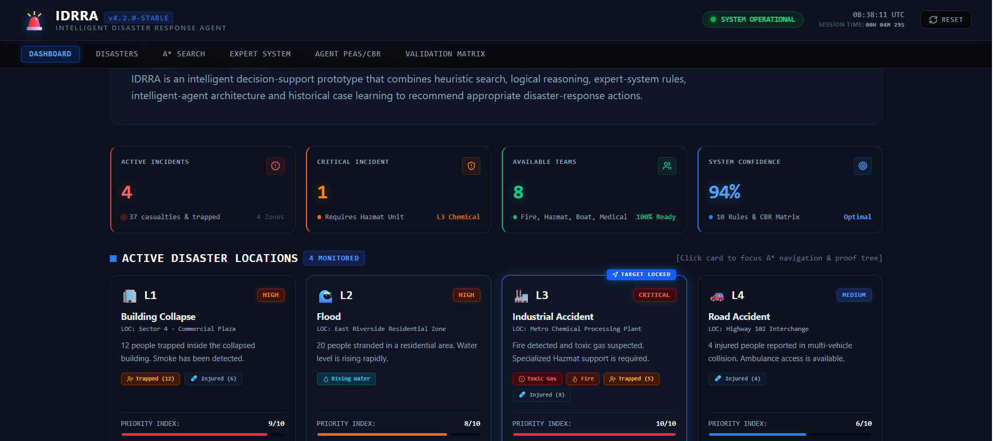

2.EXPERT SYSTEM
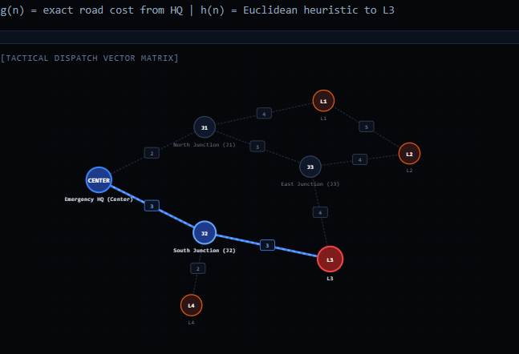

3.A* SEARCH

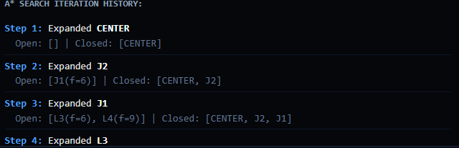

4.PEAS

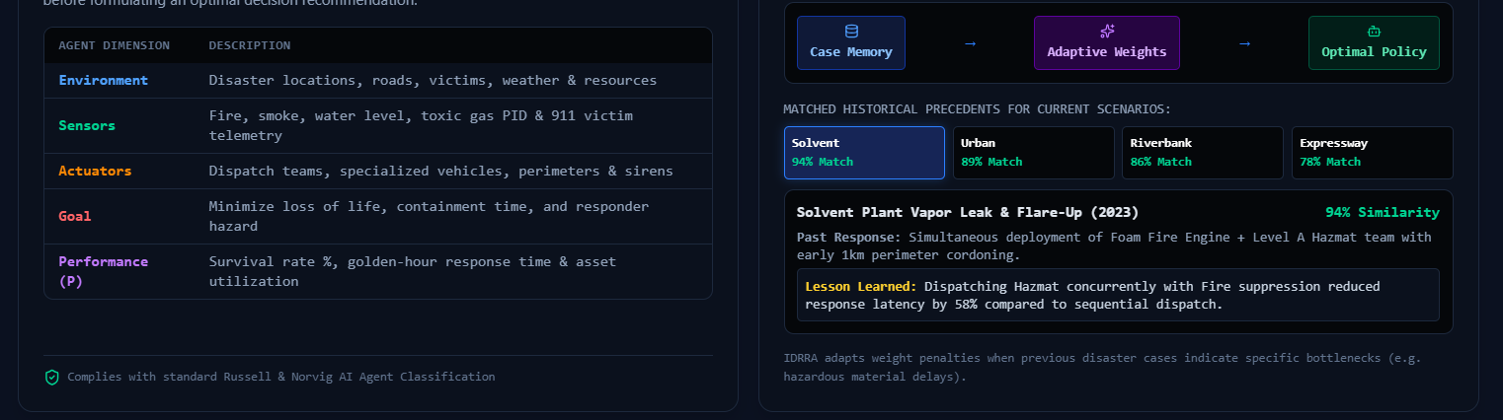

5.VALIDATION MATRIX

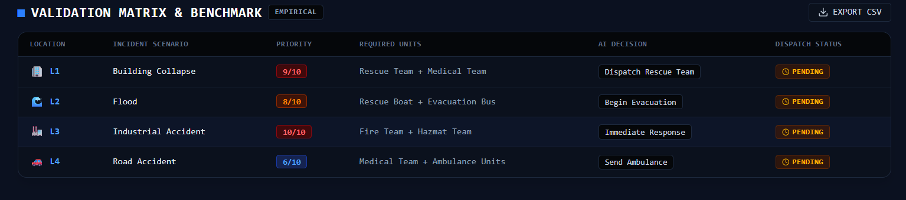

6.WEBSITE LINK

https://aistudio.google.com/app/apps/56eaaf0f-767f-4a5c-adc7-44658241a736?showPreview=true&showAssistant=true&fullscreenApplet=true

